Crochet BEE’s for survivors of sexual violence

When a survivor leaves our support services, we like to mark their achievement with a care package. This can include some well-being items. Bee’s have long been a symbol associated with our service, due to our youth activist group.
Recently we have begun crocheting bee’s as mini emotional support toys.
Below is a pattern for the Bee – if you want to have a go. You could make them for yourself or if you wish you could make them and then donate them to the service for distributing to survivors.
For donations post to 11 Hill Lane, Lerwick, ZE1 0HA
Or email contact@compasscentre.org

Pattern notes: This pattern is made using UK notation and is crocheted in a continuous round. When changing colour, in the last stitch of the round, insert the hook through the next stitch as normal and draw yarn through. Use the NEW yarn colour to make the final wrap to complete the stitch. As you move to the next stitch, give the previous yarn colour a gently tug to tighten the stitch.
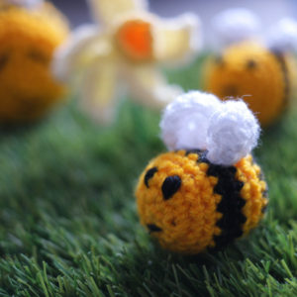
Materials:
4mm crochet hook.
Small quantity of black, yellow and white DK yarn
Small quantity of toy stuffing
Wool needle
Abbreviations:
DC – double crochet
HTC – half treble crochet
TC – treble crochet

Body
Using yellow yarn, make a magic ring
Round 1: Work 6 DC into your magic ring (6 STS)
Round 2: Work 2 DC into each of the 6 stitches (12 STS)
Round 3: *DC in next stitch, 2 DC in next stitch. Repeat from * 5 more times. (18 STS)
Rounds 4-5: DC around. Change to black in very last stitch as described in notes above. (18 sts)
Rounds 6-7: With black, DC in each stitch. Change to yellow in last stitch. (18 sts)
Rounds 8-11: With yellow, DC around. Change to black in last stitch. (18 sts)
Round 12: With black, DC around. (18 sts)
Stuff bee and continue stuffing as you complete the remaining rounds.
Round 13: *DC in next stitch, DC next 2 stitches together. Repeat from * 5 more times (12 sts)
Round 14: DC next 2 st together. Repeat 5 times (6 sts).
Round 15: DC next 2 st together. Repeat twice (3 sts).

Fasten off, leaving a long enough length for sewing up the bee. Make sure bee is firmly stuffed, then thread wool needle and sew the opening closed, fasten off and weave in end.

Wings (make 2)
With white yarn, make a magic ring.
Round 1: Inside the ring, work the following: DC, HTC, TC, 3 TC, TC, HTC, DC.
Cut yarn, leaving enough length for sewing to the body. Sew the beginning and end of the wing together and attach onto the top of the body behind the first stripe, slightly off centre.
Finish off and weave in ends. Repeat for the 2nd wing a few stitches apart.

